NATIONAL REGISTER OF MENTAL HEALTH CONSUMER AND CARERS

The National Register is a pool of 60 trained mental health consumer and carer representatives from across Australia, who work at the national level to provide a strong consumer and carer voice in the mental health sector.
Representative profiles have been shared to highlight the wealth and diversity of skills and experience across the National Register membership.
If your organisation is seeking consumer and carer representation, please visit our website to find out more about the selection process.
Please note that all requests for representation will be referred to the consumer and carer driven selection process - it is not possible for an organisation to request an individual representative.

Further information
- Is your organisation seeking a mental health consumer and / or carer representative?
www.mhaustralia.org/general/your-organisation-seeking-mental-health-consumer-and-or-carer-representative

- Find out more about the National Register:
www.mhaustralia.org/report/national-register-mental-health-consumers-and-carers

- View representative profiles online:
www.mhaustralia.org/general/national-register-member-profiles

Suzie Adam - Carer Representative, VIC
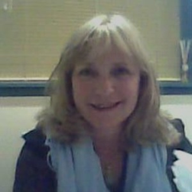
My name is Susan Adam and I am one of the original National Register members, and was honoured to be chosen for a third time to represent the grass roots issues of Mental Health Carers on the Mornington Peninsula. In 2010 I was elected President of the Peninsula Carer Council Inc., one of the largest volunteer Carer Support Groups in Australia with a membership of over 150.
I was one of the first Family Carer Consultants at Monash Health and set up the Family Engagement programs at Frankston and Dandenong Youth Prevention and Recovery Care Services.
I hold a Master of Social Sciences in Family Therapy after completing a B.A. in Psychology and Humanities whilst caring for three family members living with various physical and mental health conditions, and finding that there was nowhere I could go for support.
I have held many advocacy roles over the years, a recent favourite being Co-Chair of the Mental Health Coordinating Council workgroup for the Cert IV in Mental Health Peer Work. I am a member of the Expert Reference Group for the Department of Health; evaluating the National Early Psychosis services and the Peer Workforce Development Guideline Project for the National Mental Health Commission. I have learned so much from my representative roles and am currently enjoying being on the Steering Committee for Primary Mental Health Care Data Reference Group.
In my very limited spare time I thoroughly enjoy my grandkids, yoga, painting, my garden, going to live music concerts and the theatre.

Julie Anderson - Consumer Representative, VIC
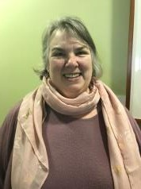
Julie Anderson is Senior Consumer Advisor in the Office of the Chief Psychiatrist and the Office of the Chief Mental Health Nurse in Victoria. She is currently on the Board of Directors at the Victorian Institute of Forensic Mental Health (Forensicare) and a past Chair of Neami National (2000-2012). Julie has advised Federal and State Governments on mental health policy, she was a member of the writer’s group for the 5th National Mental Health and Suicide Prevention Plan and spent 2 years on the National Mental Health Services Framework Advisory Group. Julie is a member of the Victorian Government Lived Experience Advisory Group. She is a graduate of the National Mental Health Commission’s Future Leaders in Mental Health Program 2014-2015. Julie is experienced in consulting and advocating with people who have a mental illness about services and would say it is the best part of her job.
Lynette Anderson - Carer Representative, NSW
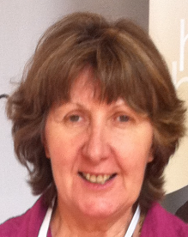
I have 30 years of ‘lived experience’ caring for a loved one with mental illness and 15 years working with the Mental Health Industry in various capacities. As a Carer Support Worker for several years I facilitated a carer support group. Since 2012 I was a Project Manager for Mental Health Carers NSW, and after leaving this position I became their Board Member.
After completing Certificate IV in Mental Health Peer Work, I now work as a Carer Peer Worker for Northern Sydney Local Health Districts.
I as a founding member of the Carers Network Northern Sydney have sat on hospital committees in the Northern Sydney area since 2009.
I am also a carer consultant on committees in the Northern Beaches area including the Community Health Centre, One Door, Your side and CCNB. I have been a Board Member of CCNB. I am a Carer Representative for Carers NSW
Previously I taught high school Literature. History, Communications and Law and later Certificate IV in Real Estate in TAFE. I am part of the MHIT Mental Health Intervention team informing NSW police on mental health.
I also work with the Mental Health Commission NSW on projects such as the recently published “Lived Experience” Framework for NSW. I am a member of the Commission’s Community Consultative Committee.
As a member of Mental Health Australia’s National Register I have a passion for human rights, education, justice and equality for the mentally ill.

Anne Barbara - Carer Representative, SA
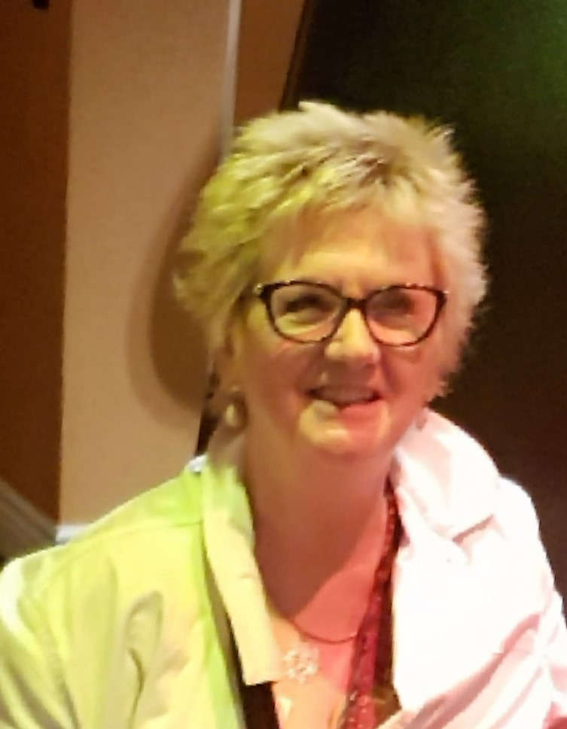
I am a passionate advocate for the lived experience voice being heard and most importantly acted upon and have been very active in the mental health arena for over fifteen years. My employment as a Carer Consultant within SA Health, in both an acute and subacute clinic, for the past thirteen years has ensured my understanding of current carer issues remains relevant.
I continue to attend numerous mental health consultations and presentations to keep my skills and knowledge up to date and am fortunate to have had the opportunity to deliver the lived experience perspective within the service I work on an increasing basis, owing to a passionate lecturer who values the lived experience voice and perspective.
I eagerly awaited the introduction of the NDIS and read extensively about it prior to its implementation, enabling me to be well informed and knowledgeable of its benefits and the application process. Utilising my knowledge I have been proactive in supporting Carers by assisting them and their loved ones to understand the NDIS benefits and process as I am concerned the NDIS is not currently reaching as many consumers with psychosocial disabilities who would benefit from its support.
I am eager for my involvement within the mental health arena to continue to contribute to stigma reduction and bring improvement to people impacted by mental illness.
Judy Bentley - Carer Representative, ACT
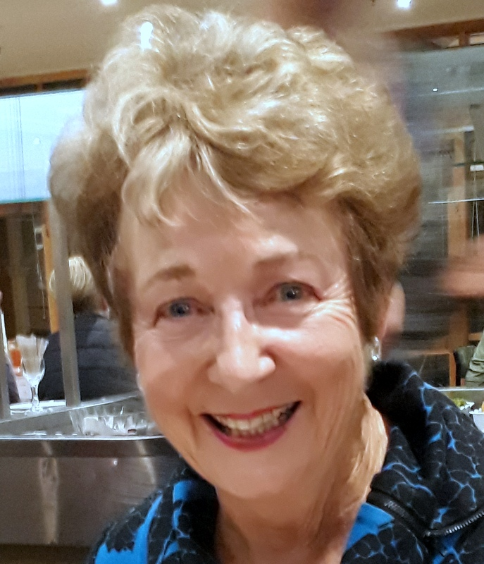
As carer for a close family member since 2001, my membership of the National Register since 2007 has been vitally important, with opportunities to share support with National consumers and carers and participate in National Committee representation.
I was ACT Carer representative on NMHCCF from 2005-12 and returned to the Forum in June 2019 as carer representative for Private Mental Health Consumer Carer Network. I am ACT co-ordinator of PMHCCN and Board Member.
I am Carer Member of the Million Minds Mental Health Research Mission Advisory Panel, tasked by the Minister for Health to provide strategic advice on the allocation of Medical Research Future Funds to targeted mental health research.
I represent carers on Department of Health’s National Assessment, Triage and Referral Project, developing national guidance material and resources to support Primary Health Networks to implement assessment, triage and referral systems for individuals presenting for mental health services.
ACT representation includes: Mental Health Minister’s Advisory Council; Richmond Fellowship Board; Collaborative Engagement Forum of Adult Mental Health Unit; Capital Health Network’s Partners in Recovery Consortium; lecturer final-year Australian National University medical student Academic units Psychiatry and Addiction Medicine. Active participant and member ACT community sector mental health support organisations.
Evan Bichara - Consumer Representative, VIC
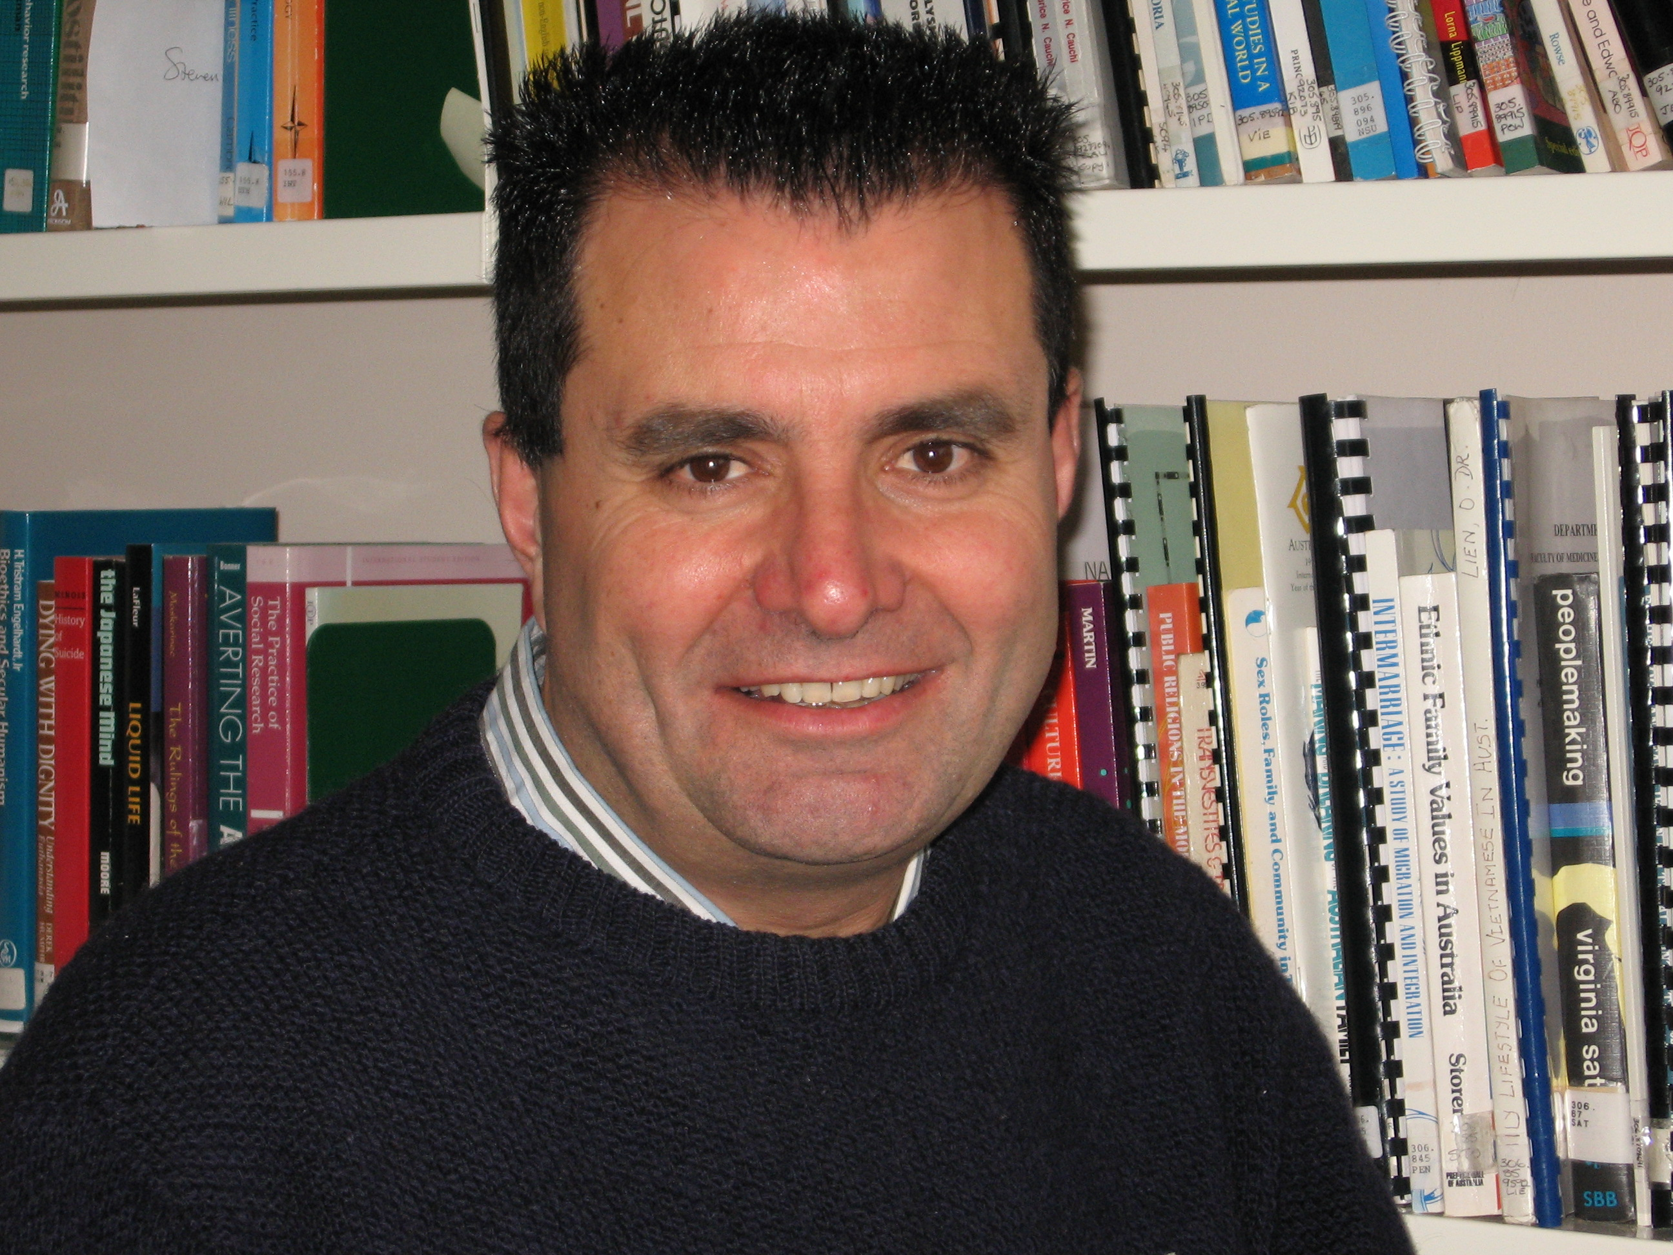
Evan is a long time MH Consumer Advocate for the diverse Australian populations, including the mainstream.
Evan has extensively studied his field well having attained a Certificate IV in Community Disability Services trained in working closely with people who require special needs. Evan further attained a Diploma in Community Development, a Post Graduate diploma in Case Management.
With encouragements from friends, family and neighbours Evan per sued into Mental Health following a setback & from his scientific studies in obtaining a MH Advocacy role within the Victorian Trans-cultural MH Service within the St Vincent’s Hospital serving all the Multicultural communities at local state and federal levels. In that role Evan ran successfully 2 major Cultural groups for 16 years.
Evan’s passion is bringing healing to people who have been through a rough experience. Evan helps people including their families to find healthy perceptions & strengthen their relationships so that peace, whole & safe mediums can be linked by community. Evan knows that there is no single approach that is right for every individual….so Evan has been in the job trained on numerous modalities of approaches in getting people back on their feet.
Michael Burge – Consumer Representative, QLD
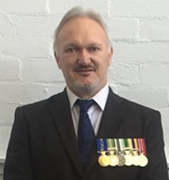
Michael Burge OAM was awarded Order of Australia Medal (OAM) June 2014 for his work as a Mental Health Advocate since 1995. He has represented consumers on numerous local, state, national and international committees. He is the former Chair of the National Mental Health Consumer & Carer Forum (NMHCCF) and member 2006-2017. He is a master Mental Health First Aid Instructor, having conducted 102 courses throughout rural and remote Australia.
Michael is a graduate of the National Mental Health Commission’s Future Leaders in Mental Health Program 2014-2015; member of the International Initiative for Mental Health Leadership (IIMHL); and has participated in exchanges to America, Canada, England, Ireland, Scotland and New Zealand. He was appointed to the World Federation of Mental Health (WFMH) board 2017-2021. He presented on a Lived Experience Panel at World Congress of Mental Health in November 2017 in New Delhi, India; and attended the WFMH Conference in Houston, Texas 2018.
Michael is presenting on “Value of Peer Work” and running a course in Wellness Recovery Action Plans (WRAPs) in Buenos Aires, Argentina in November 2019. Michael has also accepted new appointments as a WFMH board member and VP Programme Development from November 2019.
Michael believes discrimination against people with a lived experience of mental health in workplaces could potentially be the biggest modern-day systemic failure with regards to consumer rights in Australia and around the world.
Sonia Di Mezza – Carer Representative, ACT
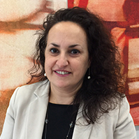
Sonia Di Mezza is the Deputy CEO of the ACT Disability, Aged and Carer Advocacy Service (ADACAS), an advocacy NGO that provides advocacy for older people; people with disability and people with mental health illness. She is a human rights lawyer and solicitor, and has set up human rights projects in Sudan, and Pakistan, worked for a child rights NGO in India, for the UNHCR in Lebanon and as a refugee lawyer in Australia. In the ACT Sonia manages a team of advocates that support people with mental health illness and manages the Redress support team. She holds a Master of International Law, majoring in human rights law.
Judith Drake - Consumer Representative, VIC
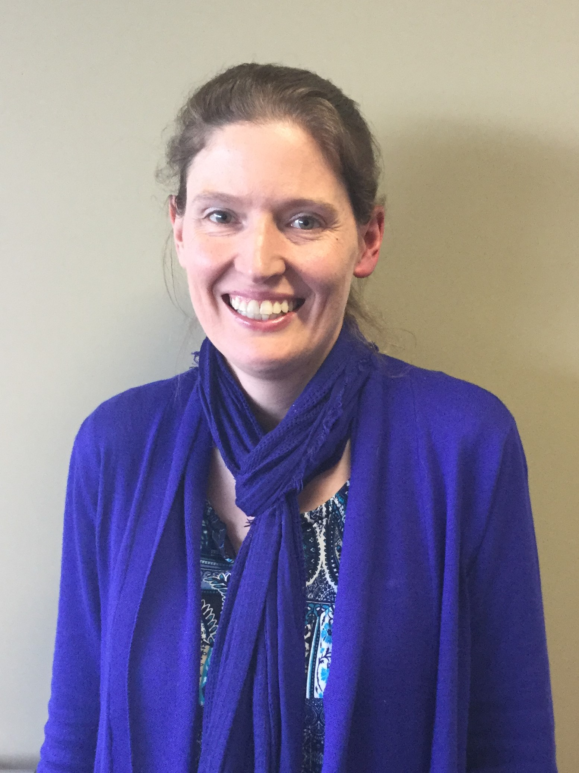
I’m a Melbourne-based, independent consumer advocate passionate about social justice, community inclusion and mental health reform. I have extensive experience across diverse areas including reference/advisory groups, research and evaluation, support group facilitation, training, events, document/website review, peer support (including with volunteer emergency service workers) and family violence prevention.
I regularly attend conferences around Australia & have presented on diverse topics: NDIS, consumer participation, trauma-informed practice, dissociation, self-care, disclosure, mental health service improvement, self-harm, Hearing Voices approach.
I hold qualifications in psychology, business, and training & assessment and have completed additional courses such as Applied Suicide Intervention Skills (ASIST), Intentional Peer Support (IPS), Alternatives to Suicide and Consumer Leadership.
Current interests include NDIS and psychosocial disability, national standards for digital mental health, and how emergency services interact with people experiencing mental health challenges. Highlights include helping coordinate the consumer-led, multi-disciplinary World Hearing Voices Congress (2013, Voices Vic), receiving a Mind Community Award (2016) for Outstanding Contribution by a Client to Service Improvement, a special commendation for my ePoster at TheMHS (2015), and being on Victorian Mental Health Tribunal Advisory Group (TAG).
I believe in working collaboratively, respectfully and authentically to bring about real change that improves people’s lives.

Jessica English – Consumer Representative, NSW

I am a passionate consumer representative and advocate with a background in lived experience leadership across the public, community managed and non-for-profit sectors for the last 9 years. I have represented consumers at all levels from local, state, national and international committees, including representation on key steering committees with national programs and executive committees.
I have a background in youth peer support working in public health inpatient settings, peer education, online mental health services and consumer representation. I have held policy, project and systemic advocacy roles with mental health peaks across Australia, with a keen interest in youth mental health, online mental health support, peer work, suicide prevention and service improvement.
I am an advocate for lived experience driven change and improvement within mental health services, including the growth of peer support in mental health services, promotion of recovery oriented practice and stronger engagement of consumers in service delivery.
Irene Gallagher – Consumer Representative, NSW
I have passionately worked in the mental health sector for over twenty years, first as a volunteer, then in clinical practice, until I had an opportunity (under clinical supervision) to identify to a client that I had a lived experience. This opportunity changed the way I worked and saw a redirection of career and I have worked as a peer worker since that time, which have included roles in senior management in the NGO sector and the public sector.
I have worked in the capacity of developing and managing a District wide peer workforce with a local health district and was instrumental in setting up the South Eastern Sydney Recovery Collage. I am currently a Director of a number of Boards and committees in NSW.
I have am the Chief Executive Officer (CEO) of Being | Mental Health and Wellbeing Consumer Advisory Group, the NSW peak organisation for people with a lived experience of mental health issues and we work to achieve and support systemic change in the mental health sector. I also am the founder of a peer led organisation, Peer Work Matters, which focuses on developing the mental health peer workforce in NSW.
My passions lay in the areas of trauma informed practice, seclusion and restraint and in developing the peer workforce, ensuring the peer workforce are valued and heard, not harmed in their workplaces, and have the supports they deserve and need.

Daya Henkel - Consumer Representative, NSW

I have worked as a consumer advocate and mental health peer worker within the public, private and community managed sectors for almost 15 years. My work has consisted of consumer representation from a local to a national level and I am currently the NSW Consumer Representative on the National Mental Health Consumer and Carer Forum (NMHCCF). I am honoured to walk alongside peers on their journey and raise consumer perspectives at a national level.
I currently work for the National Mental Health Commission in the Mental Health Reform Team, leading work around peer workforce development and reducing restrictive practices. I am passionate about growing the peer workforce and recovery-oriented, trauma-informed care. I bring my experiences as a person with lived experience of mental distress and recovery, a survivor of trauma, and an LGBTIQ+ person from a rural community to the National Register. I am strongly committed to advocating for positive change in the mental health system, and I am hopeful of a time where choice and empowerment are key principles across the sector.
My previous appointments include representative positions on the Mental Health Commission of NSW’s and HNECC PHNs Advisory Councils, and I am a prior Chair of the NSW Public Mental Health Consumer Workers’ Committee. My qualifications in psychology, social welfare and peer work complement my work in the mental health sector.
Fay Jackson – Consumer Representative, NSW
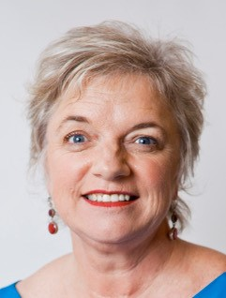
I currently hold two positions. They are as Deputy Commissioner with the NSW Mental Health Commission and General Manager of Inclusion at Flourish Australia. I have worked extensively in the public mental health system including at the front lines as a Peer Worker, as a manager and in executive positions.
I have broad knowledge of the public and NFP, CMO mental health services within Australia and increasingly in International services. I also founded Vision In Mind which delivers consultancy and training to workplaces, services and the community about mental health and wellbeing.
I have received a number of state and national awards over the years for my work in advocacy and education in mental health including the Meritorious Service to Community Medal. I have also appeared on ABC's Q&A, the ABC's One Plus One, and many radio and press interviews.
I have personal lived experience of mental health issues, recovery and reclaiming my citizenship. I love being a tax payer! I have also lost loved ones to suicide.
We need to see mental health and wellbeing as a whole of life, whole of health, intergenerational, whole of community and whole of government concern. I believe that recovery is about human rights as much as it is about personal wellbeing.
Juanita Koeijers – Consumer Representative, WA
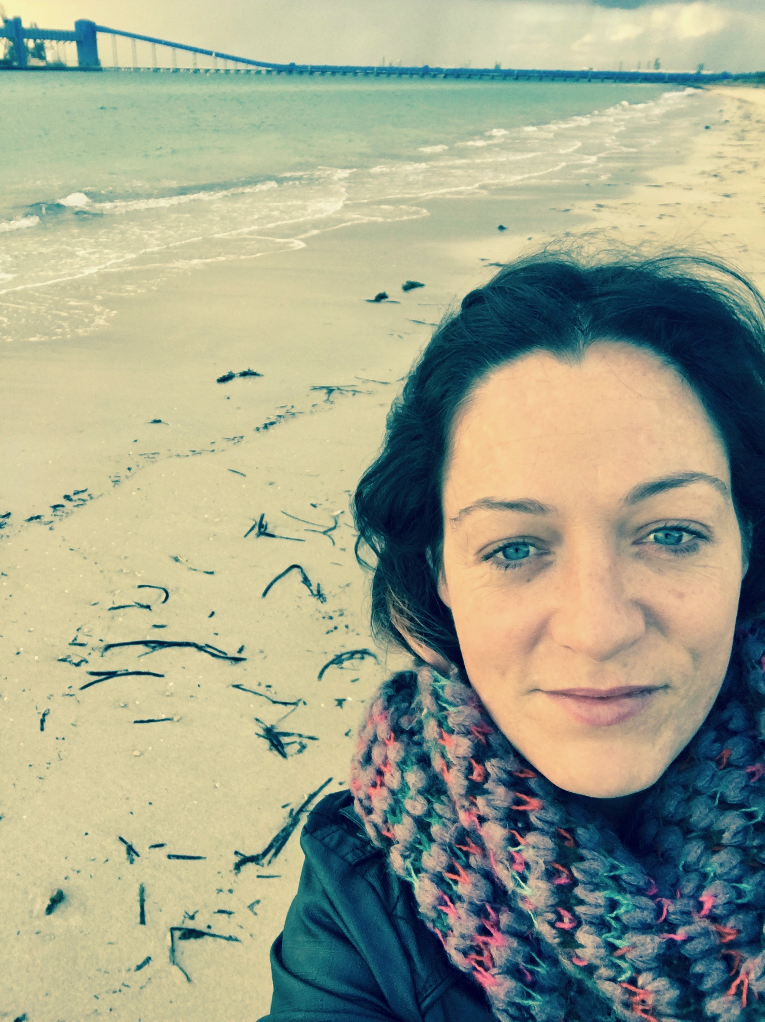
With a background in community and drug and alcohol services, I am currently completing university studies in nutrition and natural therapies with the hope to progress holistic services within mental health. I have been an active consumer representative, primarily from an AOD space, for the past three years where, among other things, I advocate for development, recognition and broader implementation of the peer workforce.
I currently hold positions on a variety of committees one of which is working toward an AOD consumer peak in WA.
I am passionate about the engagement of community consumer populations in relation to new and emerging research and hold a position on the data monitoring board for the National Drug Research Institute’s current national clinical trial for N-acetyl cysteine as a potential pharmacotherapy for methamphetamine dependence. My personal belief and focus is on creating opportunities for relationships and connection within the community through food, health, art, education and the sharing of stories as a primary, preventative strategy.
Matthew Martin – Consumer Representative, ACT
I have been a consumer representative with the ACT Mental Health Consumer Network for over five years. I came to the Network following a psychotic episode which found me incarcerated where upon I was diagnosed with Bipolar disorder. Since that time I have been heavily involved with the mental health community engaging in systemic advocacy for appropriate mental health, vocational, housing and employment services throughout the ACT. Prior to my psychotic episode I was a teacher. Following my episode, I experienced stigma both personally and throughout the community as I looked to regain employment in this area. The barriers I faced encouraged me to engage in new areas of study. Since my psychotic episode I have retrained myself in the areas of accounting, commerce and law to assist to further navigate the mental health sector and advocate for others to receive timely and appropriate treatment, care and support for their needs. I look forward to engagement with other mental health consumer representatives from around the nation who have a vision to assist others with mental health needs.

Marie Piu – Carer Representative, VIC
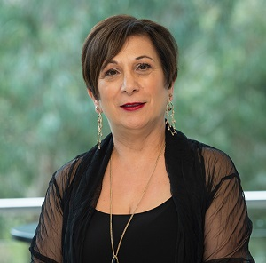
CEO Tandem – Peak body for Victorian Mental Health Carers
Marie is passionate about advocating for a health system which supports consumers, families, carers and service providers working together in partnership to strengthen outcomes for people facing mental health and wellbeing challenges. She is thrilled to be entrusted with the leadership of Tandem as she has been in a caring role for her mother since she was a young child and has firsthand experience of the power of working in partnership.
Marie is a registered psychologist and member of the Australian Psychological Society. Her postgraduate studies in Applied Psychology provided her with the theoretical underpinning and professional skills for her future focus on systemic advocacy. She has been lobbying for service improvement, accountability and family/carer inclusion in care throughout her professional career. She has worked for nearly three decades to ensure that marginalised community members, many impacted by serious mental illness and their families/carers, have access to better care and community services and that there are policies, procedures, professional guidelines, and wherever possible, an authorising environment in place to support this.
Marie has held Senior Management roles, managed multidisciplinary staff and multiple national and state-wide programs and projects in a broad range of contexts including: Community and Mental Health, Trade Union and Policing, with extensive experience and interest in working with Aboriginal and Multicultural Communities.
Lorraine Powell - Consumer Representative, WA
It is not because of, but in spite of, living with mental health issues personally, having a caring role, and the loss of a son to suicide, I have chosen to be an independent consumer consultant to encourage, influence and be a disruptive innovator in mental health reform for 15 years. Over that time, I have taken great delight in belonging to, and involved in, actual change in our services and systems which continues to motivate me.
I am very proud I was one of the first people in Australia to achieve the Mental Health Peer Work Cert IV, graduated and served as a company director for numerous organisations, and have been a member of the NMHCCF since 2012.
I am an accomplished speaker, facilitator, educator, a very keen learner, and take great delight in policy. My passion lies in being a people person, seeing strengths, prevention and promotion and fundamentally believe everyone has the right and ability to participate actively in their community of their choosing.

Yvonne Quadros – Carer Representative, NSW
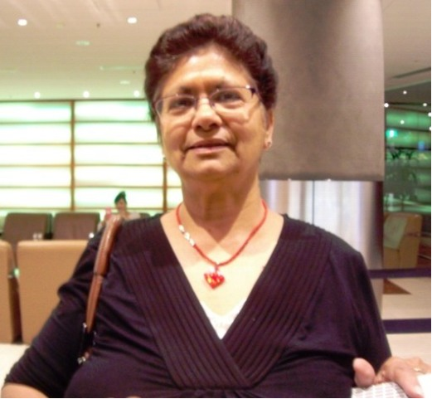
I have been a carer for a family member with a psychosocial disability for over 2 decades. My lived experience has made me aware of the benefits of being proactive with regard to seeking better services and treatment for mental illness. I actively participate in advocating and lobbing for better outcomes for our relatives and friends through involvement in local, state and national government and community committees, advisories and technical working groups.
I was a member of the NSW Mental Health Commission’s Community Advisory Council and the NSW Carers Advisory Council. I have also held roles as a NSW Official Visitor, and Carers NSW family support worker. Currently I am a Carer Representative on the Agency for Clinical Innovation Mental Health Executive NSW (ACI) and a Support Group leader, One door for carers in Regional Coffs Harbour. I share my knowledge, expertise and experience with my peers to help them navigate the intricacies of the mental health system.
My main passion is in the elimination of stigma that surrounds mental illness, restrictive practices in mental health units and the recognition of carers’ as partners in care in all aspects of treatment and service delivery for our loved ones.
Apart from my interest in advocacy and mental health, in my spare time I enjoy making art. I hold a BA in Fine Arts and Visual culture and a Diploma in Visual Arts.
Angela Rao – Carer Representative, WA
I am passionate about advocating for people experiencing mental health issues and their carers. When one of my loved ones became ill, I realised I needed help, and this led me to becoming a Carer Representative.
I was appointed to the Mental Health in Multicultural Australia (MHiMA) National CaLD Consumer and Carer Working Group as WA’s Carer representative in 2013. My work has a strong emphasis on empowering other carers and increasing their knowledge around mental illness and recovery. Being a carer advocate for MHiMA also played a part in my being selected to participate in work to implement WA’s Mental Health Act 2014.
I participated in various working groups established by the Western Australia Mental Health Commission (WAMHC) to assist with the effective implementation of the Mental Health Act 2014. In particular, the WAMHC established the Lived Experience Advisory Group (LEAG). As a LEAG member, I represented carer issues beyond my personal experience.
Recently I was invited to be part of a Reference Group for a Co-Design Workshop to engage and increase awareness of mental health issues is the CaLD community.
As a member of the CaLD community, I know that it is very important to raise our voices regarding mental health issues. Many communities in Australia have a lack of understanding of mental health issues and might look down on people who are suffering from mental ill-health. By increasing awareness, we can grow compassion towards people who are suffering and create a reduction of stigma and discrimination.
Ailsa Rayner – Consumer Representative, QLD
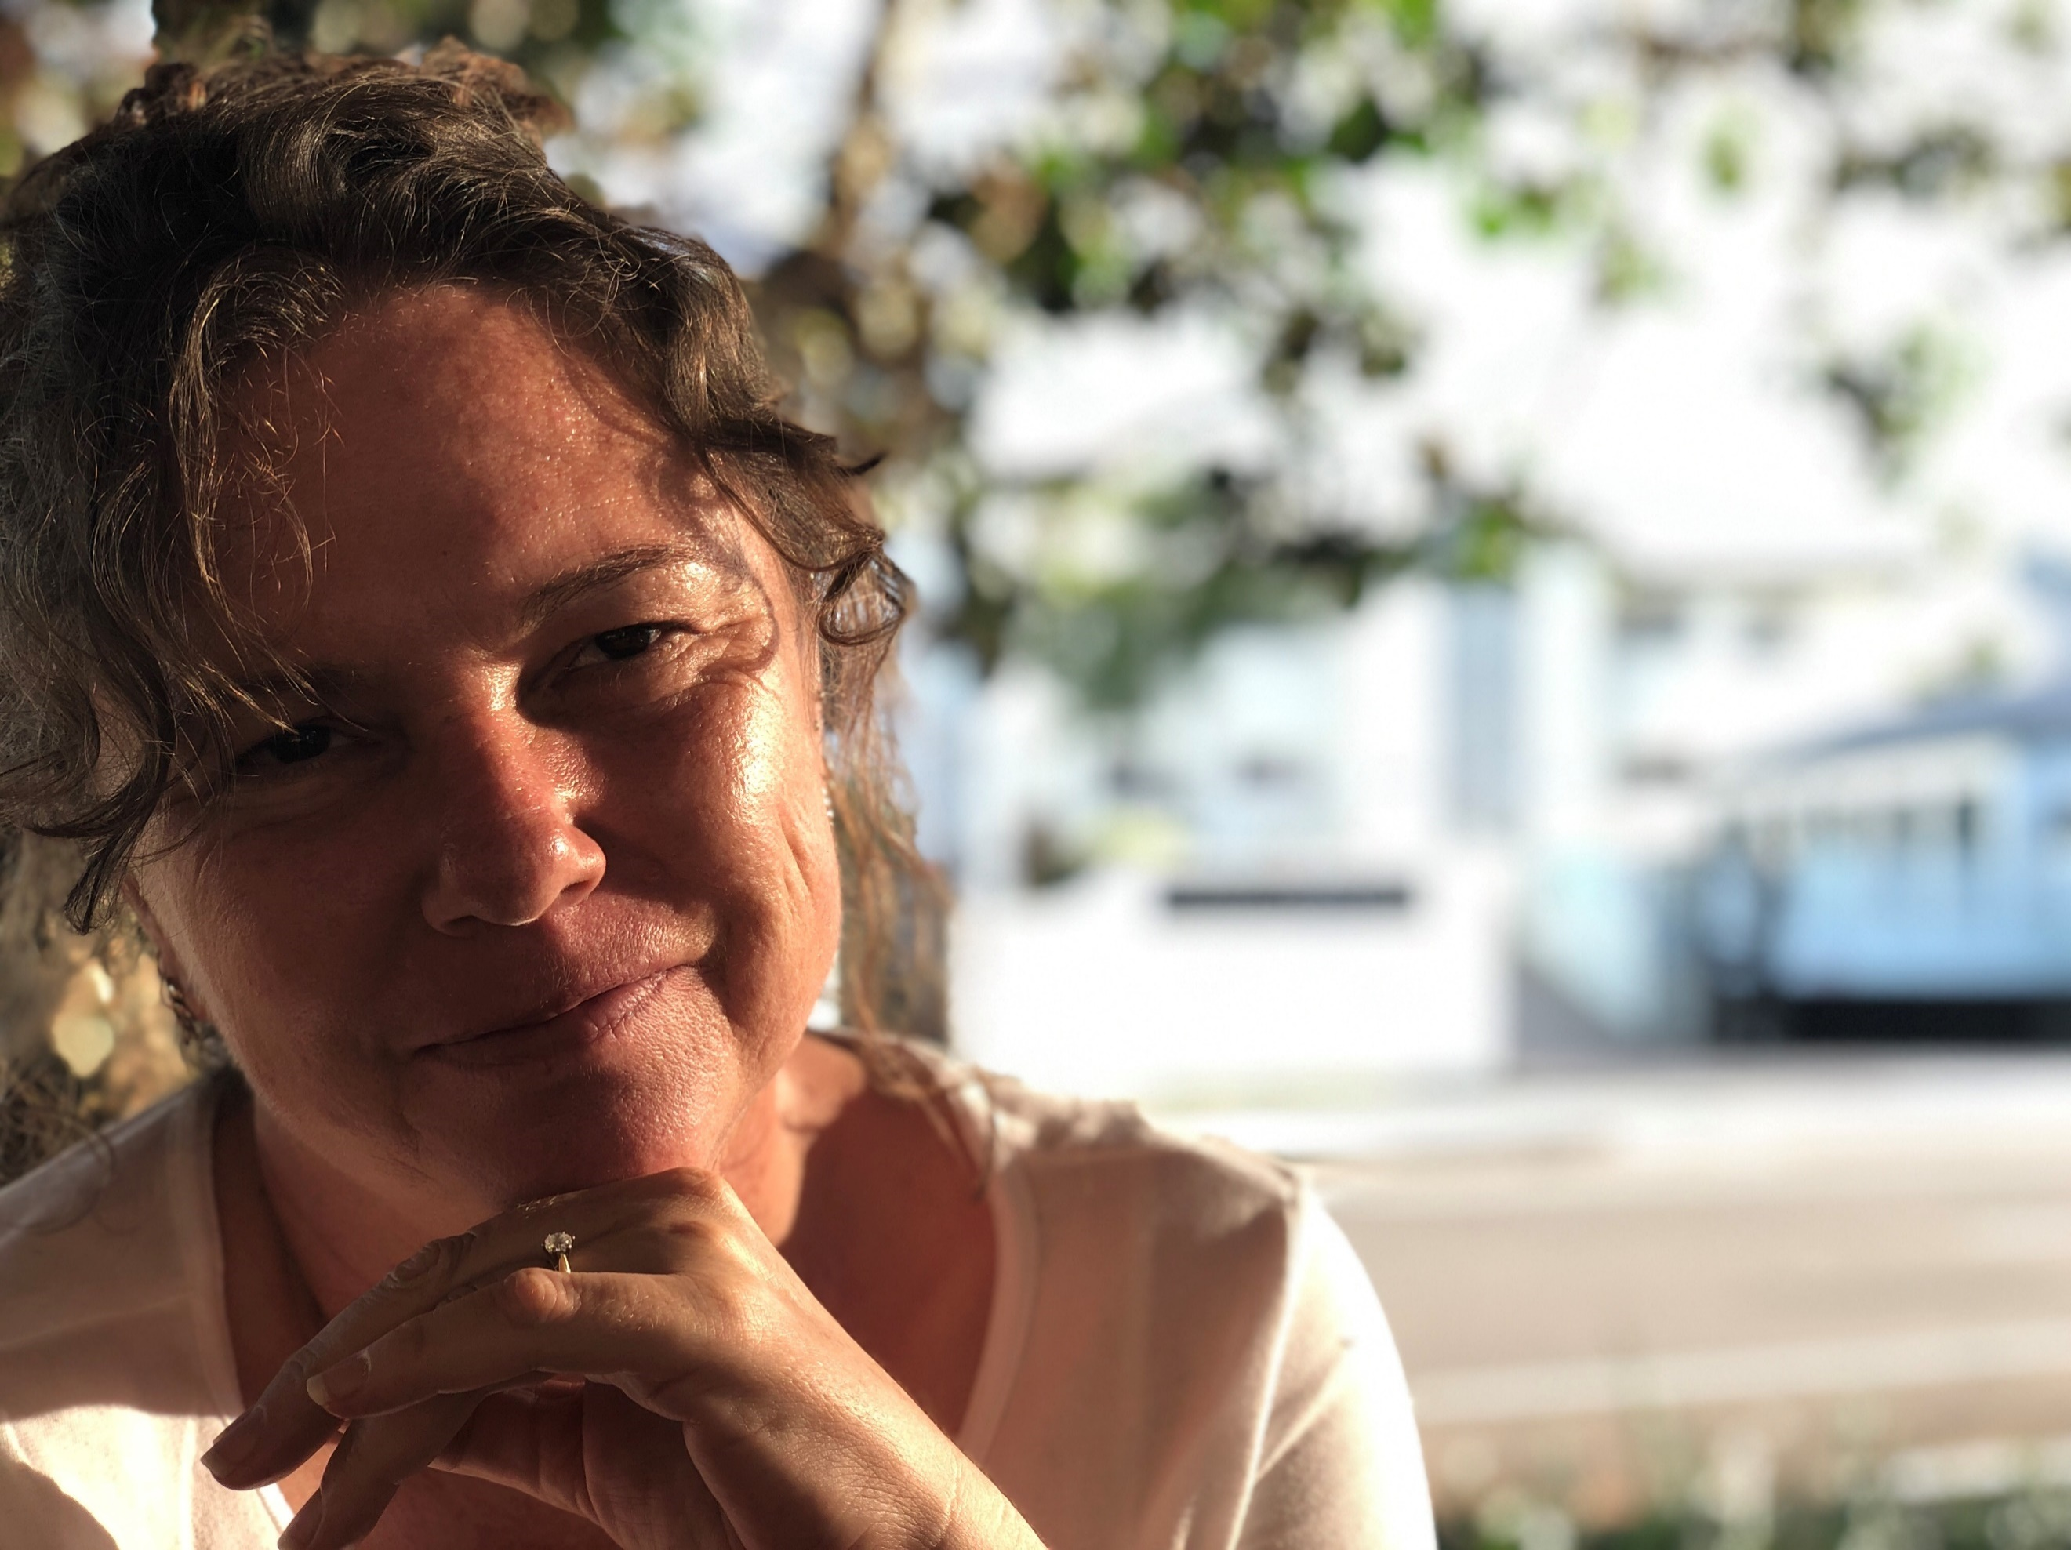
After joining the National Register in 2010 I have been very fortunate to speak at conferences, contribute at a national and state level in significant roles including being a member of a committee providing advice to COAG, being a consumer representative on the Qld Mental Health Advisory Council, and start a network online of consumers and carers through social media. These opportunities would not have arisen without the impetus from the NMHCCF and the National Register.

Nevena Simic – Consumer Representative, SA
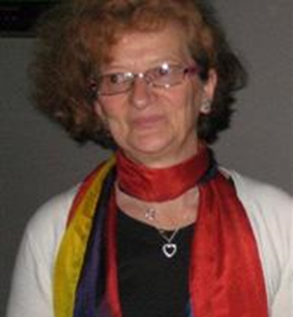
I have a strong commitment to helping others and building stronger families and communities. I give my knowledge, experience and time to provide a strong lived experience voice in the mental health sector at the national level.
My primary areas of focus are issues facing Mental Health, Wellbeing and Diversity. As an Accredited Mental Health Social Worker (AMHSW) I find real value and inspiration from working with people. The quality of peoples’ life must be the priority.
In 2007 I completed a bachelor degree in Social Work followed by a Master’s Degree in Grief and Palliative Care Counselling. I have worked in a variety of paid and volunteer positions at Government as well as at Not for Profit Organisations.
With a deep interest in issues of mental health and cultures I take proactive role. I became part of a number of groups inside the AASW and within the wide communities.
As a member of Mental Health in Multicultural Australia (MHiMA) Consumer and Carer Working Group, which operated as the project funded by the Federal government I have had advised the project and the Framework development from the South Australia experience and perspective.

Hayley Solich – Carer Representative, WA
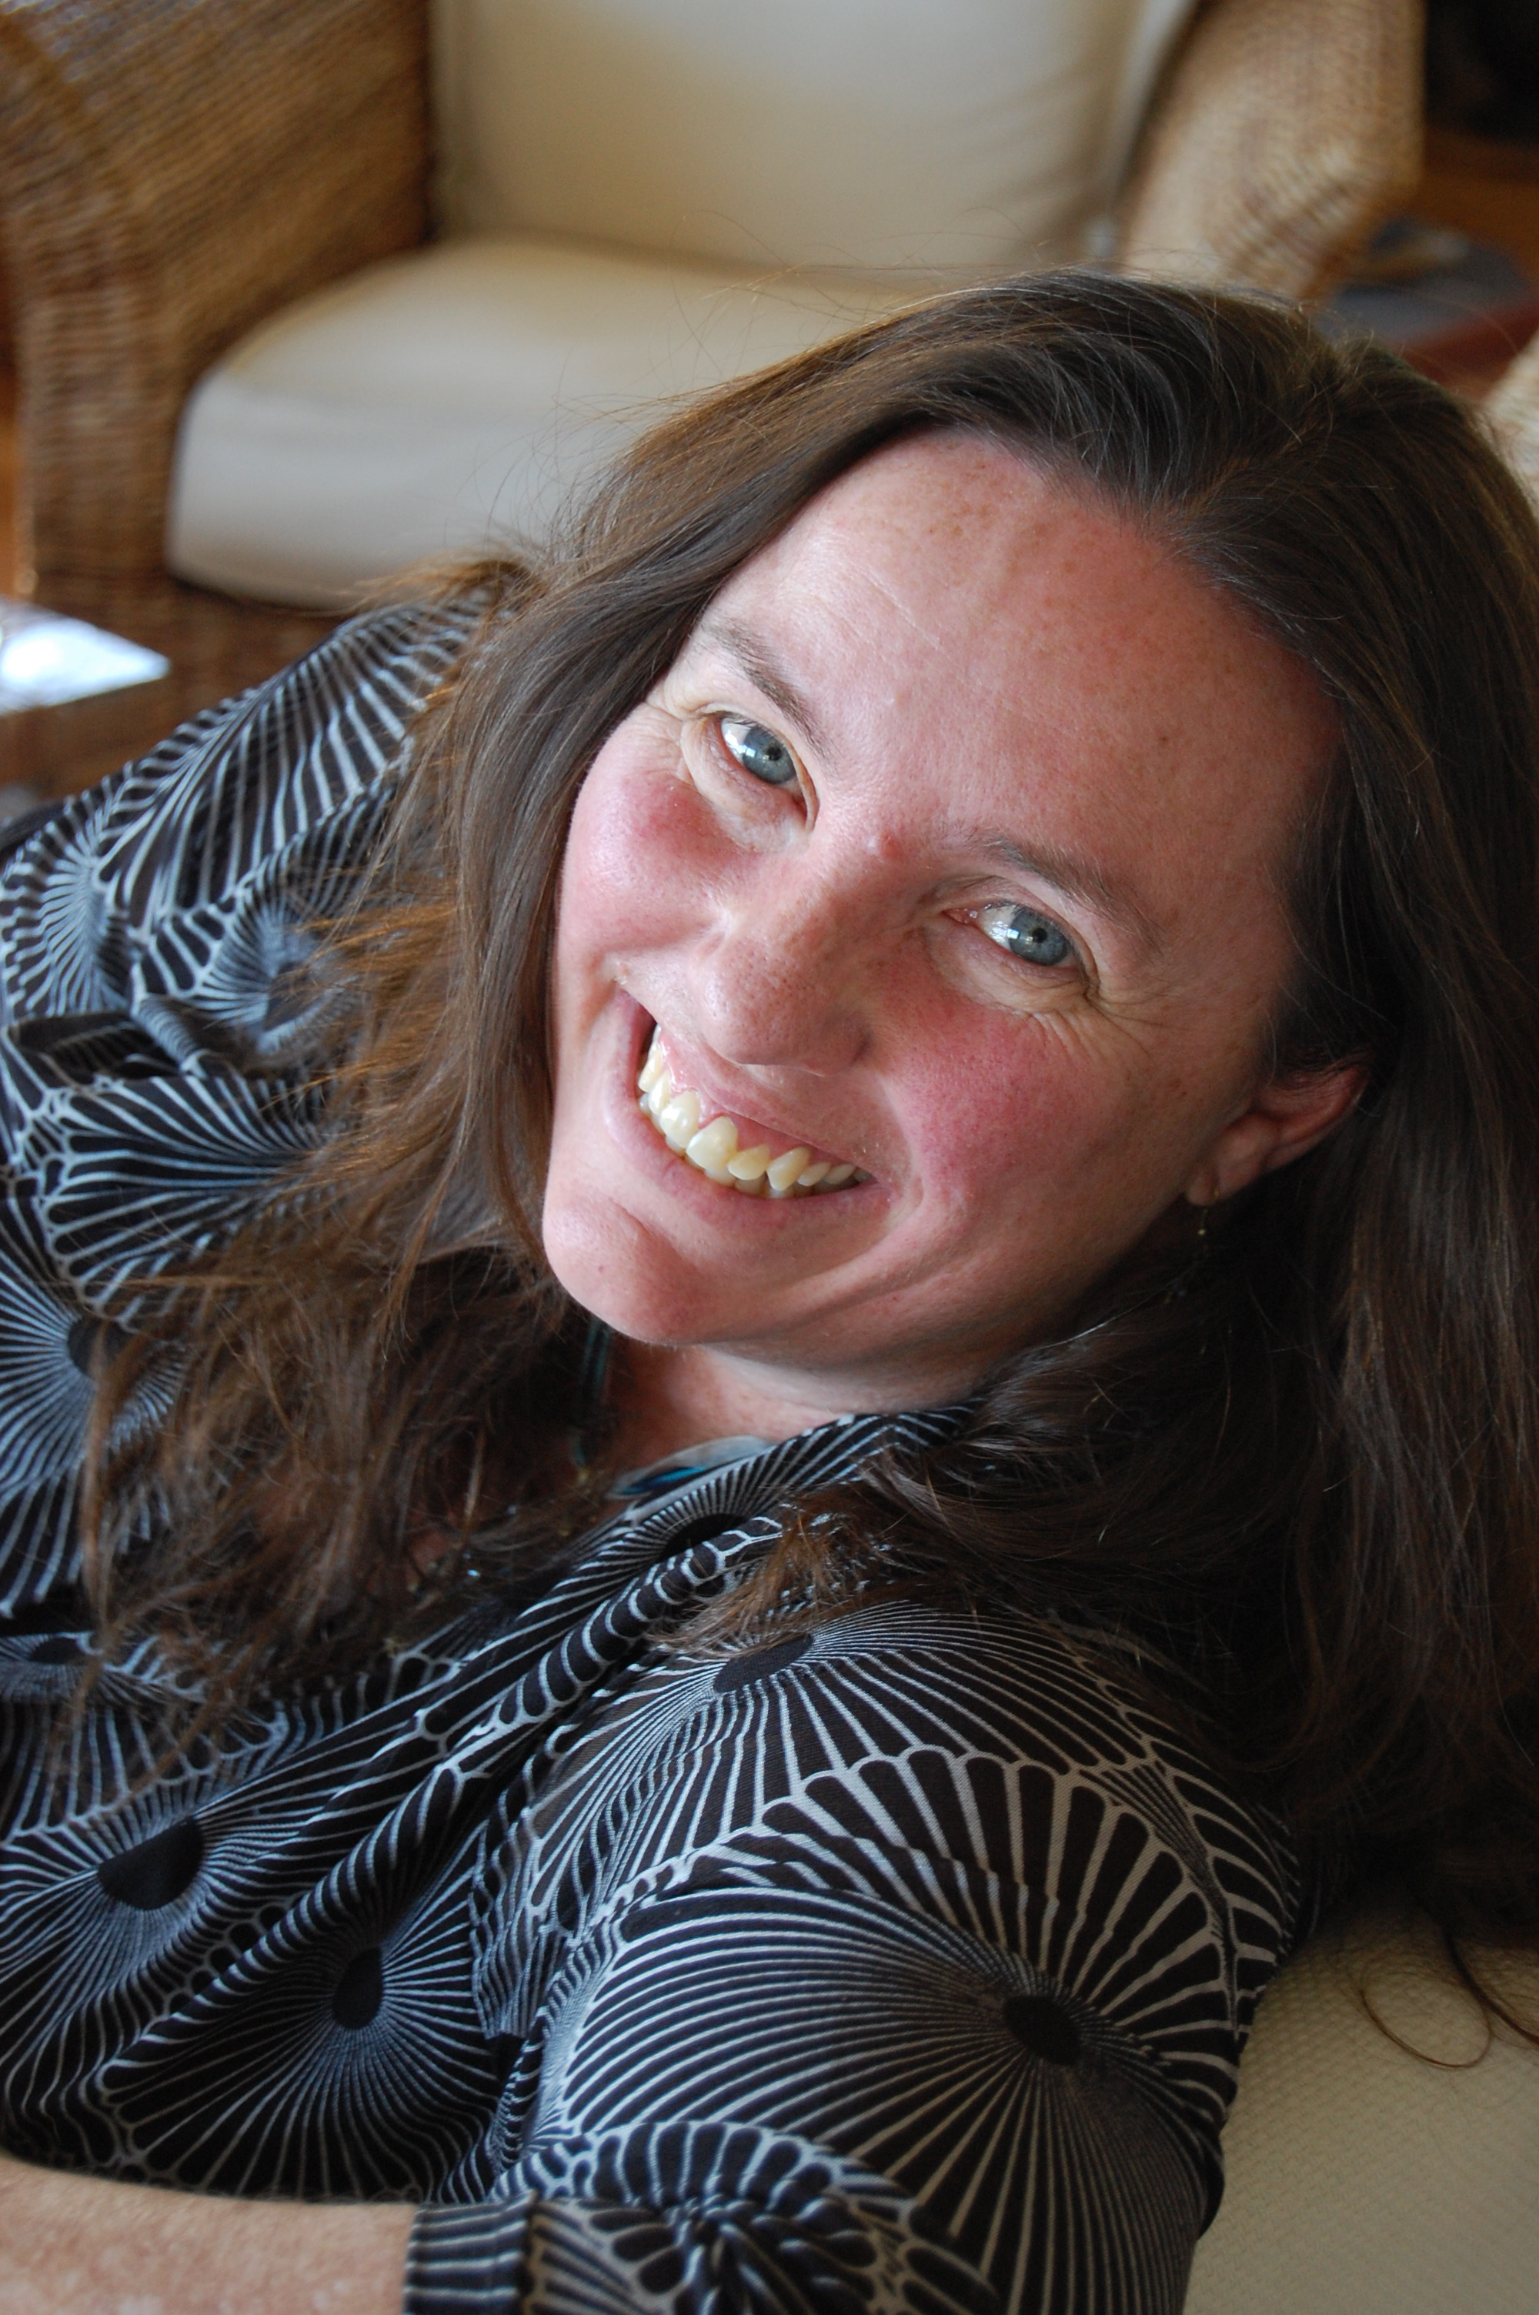
Hayley's life mottos are: "Share the wisdom that all may prosper" and "Don't just bang the table, knock on doors".
As an editor she achieved this through writing articles and interviewing interesting people; as a TAFE lecturer, it was educating her students; as a business mentor, it was helping others find their business vision and implement it successfully; and as a not-for-profit founder and Chairperson for three years, it was helping women find and take the next step in their life journey. As a carer advocate, that is coming to the meeting table full of curiosity and care, with a willingness to cast ideas into the mix and create space for others so that a better picture can be painted together.
Recipient of the Community Citizen of the Year Award 2019 - City of Stirling, and engaged on too many committees to name at the local, state and national levels, Hayley walks her talk. A strategic and compassionate leader, Hayley seeks to influence change by being part of the solution and works as a Peer Work Coordinator at North Metropolitan Health Service in Western Australia.
Pat Sutton – Carer Representative, SA
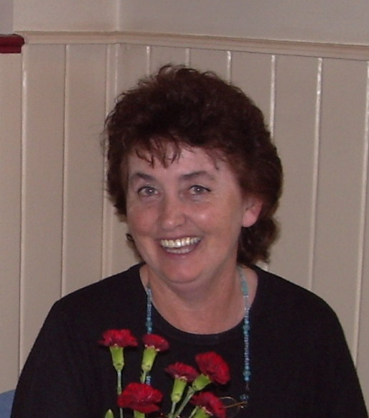
I have been an advocate for people with severe mental illness with associated psychosocial disabilities and their families for over 20 years, since my two sons were diagnosed with schizophrenia.
Driven by my strong belief in social justice, I have worked as an educator of the whole community, including service providers and professionals, within agencies and as a guest lecturer in universities, to overcome the stigma and discrimination still prevalent in our community.
I have worked for over 20 years in both a voluntary and paid capacity in both government and non-government organisations, including in a high dependency unit in Glenside Hospital, as the first Carer Consultant in the Mental Health Unit in SA Health and 12 years as Guardianship Board SA member.
I have been on numerous boards, committees and advisory groups at local, state and national level, including six years as Carers Australia’s representative on the National Mental Health Consumer and Carer Forum.
I have presented at many conferences, including TheMHS conferences and more recently those associated with the National Disability Insurance Scheme (NDIS). I was a keynote speaker at the Carers Forum at the TheMHS conference held in Auckland, New Zealand, in September 2016.
My family’s story appears extensively on internet sites and was featured in SBS Insight’s A Family Concern in September 2016.
Sarah Sutton – Carer Representative, SA
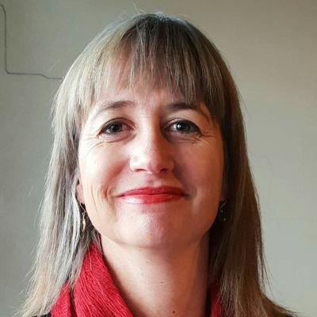
I love my family, including my two brothers whom both have diagnoses of Schizophrenia. I am passionate about mental health advocacy because my brothers cannot advocate for themselves due to their psychosocial disabilities and lack of support by mental health services. As a Clinical and Forensic Psychologist, I also advocate for carers and consumers who cannot speak out due to disability or fear of discrimination and mistreatment. I have worked for 20 years in government and private services including lived experience and expert advisory roles at a local, state and national level. I am a Board member of the Lived Experience Leadership Advocacy Network (LELAN) in SA and a Peer Ambassador for SANE Australia. I am driven by the belief that everyone deserves a contributing life, including safe and stable accommodation, support and something meaningful to do with their time. I am given hope by consumer stories of braveness and resilience, and my dream is that one day carers and consumers will be involved in co-design at all levels of mental health services, including research, evaluation, service delivery and policy.
Lisa Sweeney - Carer representative, VIC

From a young age, I have had personal experience supporting two family members with a lived experience of mental illness. This early insight into public mental health has led me to follow educational and vocational pursuits in public policy and health with the aim of improving mental health services. After working in Government for a decade, I am now working in the mental health sector in a policy and advocacy role. I also trained as a naturopath with a focus on adjunctive mental health.
I am involved in a number of mental health causes including the Board of Tandem - Victoria’s peak body for mental health carers, and Australians for Mental Health – a national grassroots mental health advocacy campaign led by people with a lived experience of interacting with the mental health service sector.
In my (not so spare) time, I really enjoy sharing my journey as a mental health carer through writing and have published blogs pieces in forums such as HuffPost. I do this in the hope it can help me make sense of some of my own experiences, as well as maybe assist other carers navigate their own situation.
My key areas of interest include psychosis, supporting young consumers and carers, and holistic and integrated mental healthcare (including promoting treatment choices).

Ãine Tierney – Carer Representative, ACT
Ãine Tierney has a personal lived experience of mental illness as both a Carer and Consumer and has been active in the mental health sector since 1995.
I have a background in performance arts, hospitality and events management. I’ve used my extensive experience to organise concerts, mental health week activities, promotional and awareness raising events for both mainstream and multicultural mental health sectors in the ACT.
I’m Executive Producer of Transforming Perceptions, a weekly radio show on 2XX Community Radio since September 2010. The show presents diverse perspectives on mental health and well-being, provides information on resources that are available for people of multicultural backgrounds. I’m a published poet. I’ve edited and compiled two books of poetry contributions by Carers and Consumers, written articles on mental health for the Canberra Times, the former MMHA’s Synergy Magazine and FECCA Mosaic.
I’m passionate about human rights, equity and equality for all Australians and breaking down barriers to improve access to mental health care for CaLD and other marginalised communities. I’m keen to find new pathways to connect with sector members and community stakeholders, and to increase CaLD, ATSI and other mental health consumer and carer representation in state and national mental health forums.
Terri Warner - Consumer Representative, ACT
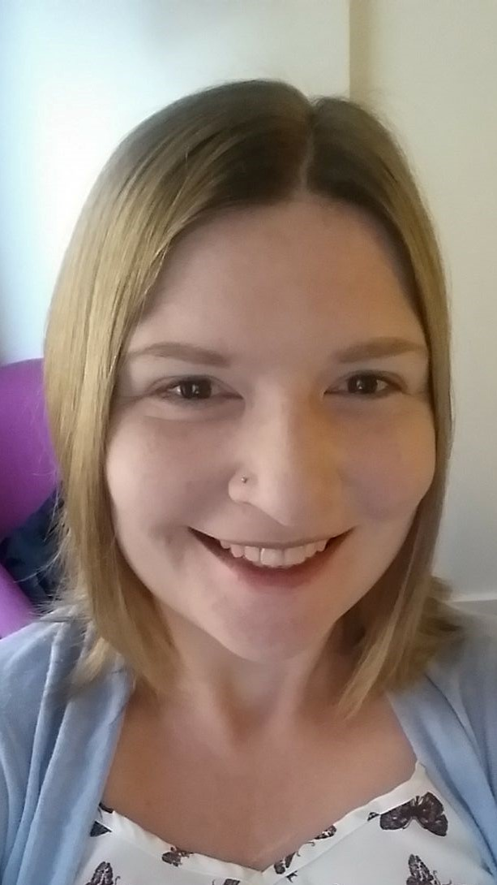
My professional background is in quality management systems auditing and the development and implementation of professional standards. I have worked in health administration as well as in mental health and disability education and advocacy. I was the Chair of the ACT Mental Health Consumer Network from 2015-2019. I have a degree in psychology and am currently studying a Master of Culture, Health and Medicine at the ANU, with a focus on health policy and systemic reform. I have personal experience of both public and private community and inpatient mental health services in both the ACT and Victoria. I believe that lived experience is the expertise that is needed to develop and deliver policies, programs and services that actually work, both for the people who use and who work in mental health services.

Jan West –Consumer Representative, TAS
I have worked and volunteered for many years in mental health and community based positions. I believe in promoting acceptance of differences and finding creative options for reducing stigma and promoting social inclusion. I retrained with a Certificate IV in Mental Health Peer Work. I have lived my life among a wide range of interesting people, many with a range of chronic health conditions. I believe in working together we can create unity.
Mental health affects us all – we all have mental health – good or not so good. I would like to see the policies, linkages and action between government, organisations and individuals to promote acceptance and inclusion in mental health, without stigma.
I have good working knowledge of social determinants of health, in particular for rural, regional and isolated communities. I have sat on and been Treasurer of Flourish Tasmania. I have extensive experience in building community and promoting total health – the integration of mental, physical, social, intellectual, emotional and financial aspects. I am a member of the National Mental Health Consumer Carer Forum. I am flexible in my availability.

Please note representative profiles are not currently available for all National Register members. The total number of consumer and carer representatives in each state and territory however, has been outlined below.
ACT – 5 members  NSW –7 members  NT – 1 member  QLD – 4 members | SA – 3 members  TAS – 1 members  VIC – 7 members  WA – 5 members

